1. Let us consider three data points (0,0) , (1,0) , (0,1) and the initial cluster centers are at the points (0,0) and the mid point of hypotenuse (0.5, 0.5) as shown in fig

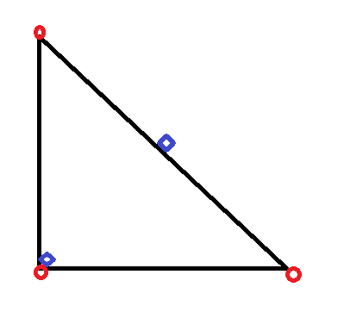

 = data point ,  = cluster centre . Now (0,0 ) will belong to cluster 1 and (1,0) and (0,1) will belong to cluster 2 and k means will stop at this point . This is local solution and its not a global solution . The global solution will have points (0,0) and (0,1) belong to cluster1 with cluster centre at (0,0.5) , and point (1,0) will belong to cluster 2 with cluster centre at (1,0) . This is an example of global convergence failure .

2 . The Objective function for k means can be written as

$F(Z_{1:N} , M_{1:k}) = \sum_{n=1}^{N}{Dist(X_{n} , M_{Z_{n}})}$

Where $Dist(X_{n} , M_{Z_{n}})$ = distance between a point and its cluster centre , $M_{Z_{n}}$ = cluster centre of data point n .

$Dist(X_{n} , M_{Z_{n}})$ can be written as the following .

$Dist(X_{n} , M_{Z_{n}})$ = $Z_{n}^{T} . {Dist}_{n}$

Where Z = [0,0,0,0,………0, 1 , 0 ,0 0,0……….] , Z contains all zeros and a 1 is present at the $Z_{n}^{th}$ position .

${Dist}_{n} = [ Dist(X_{n} , M_{1}) , Dist(X_{n} , M_{2}) ,............., Dist(X_{n} , M_{k})$]

Now we can write our equation as

$F(Z_{1:N} , M_{1:k}) = \sum_{n=1}^{N}{Z_{n}^{T} . {Dist}_{n}}$

We have our equation in the form f( x , y ) = x.y , if we have a function having the product of independent variables as value of the function than that function is a non-convex function .

Here we have $F(Z_{1:N} , M_{1:k}) as a product of two independent variables Z_{n}^{T} , {Dist}_{n}$ hence the objective function $F(Z_{1:N} , M_{1:k})$ is a non-convex function .

We Know that a non-convex function has many local optima but it doesn’t lead to a global optima

Hence all non-convex functions converge to local optima . Since our objective function $F(Z_{1:N} , M_{1:k})$ is a non-convex function it will also converge to a local optima .

**Hence K-Means Converge to a Local Optima .**